## horizontal line



Capstone Project Outline

Robotic Air Hockey System  
01.19.2018

David Eelman - 6365316  
Stanislav Rashevskyi - 7028178  
Thomas Abdallah - 7141518

Conestoga College

Electronic Systems Engineering  
Capstone Project I - EECE74125

Semester 7, Class of 2018

# Problem Statement

This project will attempt to address the problem of a lack of public knowledge about the Electronic Systems Engineering (ESE) program at Conestoga College. This problem needs to be solved in order to increase the exposure of the ESE program both within Conestoga College and in the greater public view.

# Project Background

There is limited marketing material available that showcases the technical knowledge and capabilities taught it the ESE program that can be understood by both technical and non-technical audiences. Our project will attempt to address this problem by providing a fun and interactive game that can be used for public demonstrations.

# Project Description

## Overview

The proposed project includes the design, integration, and validation of a robotic system capable of playing air hockey against a human player.

The proposed system will include mechanical, electrical, and software components. The development of this system will draw on the technical knowledge and skills learned in the Electronic Systems Engineering program while challenging the group members to learn new skills and techniques to successfully implement the project.

The mechanical portion of the system will utilize off-the-shelf components and open-source designs as much as possible. The electrical portion of the project will use off-the-shelf components (ex: motors, microcontrollers) where possible and may reference open-source designs. The software portion of the project may leverage open-source libraries (eg: OpenCV) and may reference open-source designs [1].

## Comparison to Existing Solutions

This project will serve as demonstration of the capabilities of ESE students for the general public. This project will supplement existing marketing videos [2] with a fun, interactive game that can be used at open houses and recruiting events.

## Proposed Design & High Level Specifications

This project will improve upon an existing open-source design that was implemented using hardware and software from a 3D printer [1]. The proposed system will utilize the open-source computer vision library OpenCV [3] to track the location of the puck on the playing surface and calculate its speed and trajectory. A mechanical system capable of moving an air hockey paddle in two-dimensions shall be implemented based on the design presented in the aforementioned open-source project [1]. The electrical system to control the movement of the air hockey paddle may be implemented using off-the-shelf hardware. The software to control the system shall be our own. A user interface shall be implemented to allow the system to be demonstrated to both technical and non-technical audiences. Thorough documentation and a debugging interface shall be provided to enable ESE staff members to maintain and demonstrate the project after the group members have graduated.

## System Overview Block Diagram

The block diagram shown in Figure 1 shows the major components in the proposed system design.

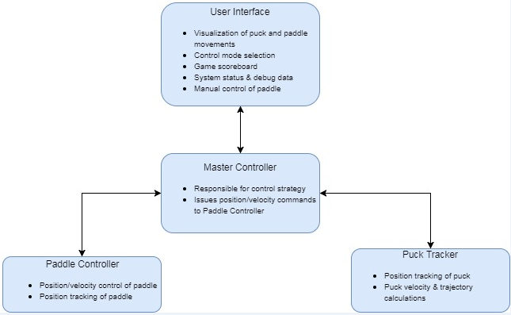

Figure 1 - System Overview Block Diagram

## 

## High Level Schedule

Figure 2 shows our intended development schedule and alignment with the ESE capstone project roadmap.

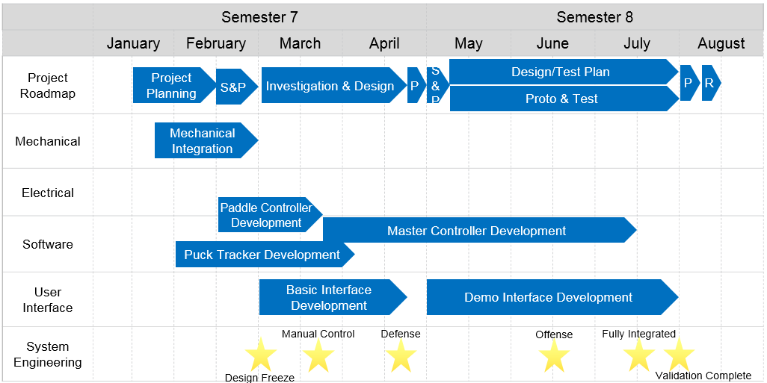

Figure 2 - High Level Schedule

## Milestones

### System Design Freeze

* Functional requirements documented for complete system
* Technical requirements documented for each module/component
* API documented for all digital communication interfaces
* Proof of concept demonstrated for key technologies
  + Vision based puck tracking
  + Mechanism for controlling paddle position

### Paddle Controller Feature Complete

* Electromechanical system capable of controlling paddle position & velocity in 2-dimensions
* Position tracking & reporting of the air hockey paddle
* Communication with Master Controller Implemented

### Manual Control of Paddle

* Manual control of paddle using proposed architecture (commands sent to Paddle Controller via Master Controller)
* User input from keyboard or gamepad

### Puck Tracker Feature Complete

* Puck Tracker capable of tracking puck position in real time
* Puck Tracker capable of calculating puck velocity and trajectory in real time
* Communication with Master Controller implemented

### System Integration Milestone I

* Functional robotic air hockey system implemented
* Basic “defensive” control strategy implemented
  + Robot only tries to stop human player from scoring
* Basic user interface implemented
  + Manual control of paddle position
  + Display of system debug data (eg: puck position, module states)

### User Interface Mockup Complete

* Proof of concept for user interface implementation
* Demonstration of technologies to be used for visualization of puck and paddle position and trajectory
* No communication with Master Controller

### System Integration Milestone II

* “Offensive” control strategy implemented
  + Robot will strategically add energy to the puck in order to try and score goals against the human player
* User interface mostly implemented
  + Ability to switch between defensive/offensive control modes
  + Visualization of puck and paddle position and trajectory

### System Integration Milestone III

* Fully integrated, feature complete system
* Robust hardware, software, user interface, diagnostics, etc

### System Validation Complete

* Requirements driven test plans written and executed

### Simulator Feature Complete (Aspirational)

* Simulated playing environment to enable testing of alternative control strategies or training a neural network
* Dynamics of Paddle Controller modelled based on real-world data
* Visualization of simulated playing environment

### Machine Learning Control Strategy Demonstration (Aspirational)

* Demonstration of a neural network trained to control paddle position/velocity in order to maximize points differential against the opponent in a simulated environment

# Budget

The total budget for this project shall be less than $500 CAD. The Air Hockey table will be donated by one of the group members’ families. Where possible the group will use hardware that has already been purchased (ex: Semester 4 robot controllers).

# Professional Support or Sponsorship

This project will have a positive impact on the ESE program by increasing the programs exposure both within the academic community, and by providing outward visibility for potential students, employers, and industry partners. This project may also serve as a platform to allow disabled people to play air hockey, or for professional players to train against.

# References

[1] Air Hockey Robot (a 3D printer hack). (n.d.). Retrieved January 16, 2018, from <https://www.jjrobots.com/air-hockey-robot-a-3d-printer-hack/>

[2] Electronic Systems Engineering Degree. (2016, January 07). Retrieved January 16, 2018, from <https://www.youtube.com/watch?time_continue=2&v=o-DjMw1MpPU>

[3] OpenCV library. (n.d.). Retrieved January 16, 2018, from <https://opencv.org/>